**Project Report Template**

**Title of Project:** AI-Based Crop Disease Detection System.  
**Name of the Innovator:** Sudeep U Kadam  
**Start Date:** 027-10-2025

**End Date: 31-10-2025**

***Day 1: Empathise & Define***

*Step 1: Understanding the Need*

* Which problem am I trying to solve?

Farmers often face major crop losses because **plant diseases are detected too late** or **misidentified**. Manual inspection is time-consuming, requires expert knowledge, and isn’t always available in rural areas. This leads to reduced productivity, poor crop quality, and financial losses.

* Who is affected by this problem?
* How did I find out about this? [Select whichever is applicable]
* Interviews
* Observation
* Online Research
* AI Tools

*Step 2: What is the problem?*

The main problem is that **farmers struggle to identify plant diseases early**, leading to delayed treatment and major crop losses. Traditional methods depend on **manual observation or expert consultation**, which can be slow, inaccurate, and inaccessible in remote areas. There’s a need for a **fast, reliable, and affordable system** to detect crop diseases automatically using technology.

Why is this problem important to solve?

This problem is important because **crop diseases directly affect food security, farmer income, and agricultural sustainability**. Early detection can help **prevent large-scale losses**, reduce pesticide misuse, and improve the overall **quality and yield** of crops. By solving this issue with AI, we can **empower farmers with accessible, real-time solutions**, leading to smarter and more sustainable farming practices.

**Take-home task**

Ask 2-3 people what they think about the project:

1. **A farmer** – He said it would be very useful if it could work offline or in local languages.
2. **A computer science student** – She liked the AI concept and suggested adding a feature for fertilizer recommendations.
3. **A teacher** – She appreciated how it connects technology with social impact and encouraged me to present it at innovation events.

*AI Tools you can use for Step 1 and 2:*

**AI Tools Used:**

1. ChatGPT – for brainstorming the project idea and defining the problem statement.
2. Google Gemini / Copilot – to research similar existing solutions.
3. Perplexity AI – for gathering real-time agricultural data and AI applications.
4. DALL·E or Canva AI – to visualize the system design or user interface.

***Day 2: Ideate***

*Step 3: Brainstorming solutions*

* List **at least 5 different solutions** (wild or realistic):
* **AI Image Detection App:** Use a mobile app with a trained CNN model to detect crop diseases instantly from leaf photos.
* **Drone-Based Monitoring System:** Use drones with AI cameras to scan large fields for diseased plants.
* **IoT-Integrated Smart Farm:** Combine AI with IoT sensors for real-time monitoring of soil health and disease prediction.
* **AI Chatbot for Farmers:** Create a chatbot that helps farmers identify diseases and suggests remedies using natural language queries.
* **AI-Powered Marketplace:** A platform connecting farmers to nearby experts and agricultural stores after disease detection for quick solutions.

*Step 4: My favourite solution:*

*My favourite solution is the* ***AI Image Detection App*** *that allows farmers to* ***upload or capture leaf photos*** *to instantly detect crop diseases. The app uses a* ***Convolutional Neural Network (CNN)*** *to analyze the image and display the disease name, cause, and possible treatment suggestions.*

*Step 5: Why am I choosing this solution?*

*I chose this solution because it is* ***simple, practical, and highly accessible****. Farmers can easily use it through their smartphones without needing technical knowledge. It provides* ***instant and accurate results****, helping them take timely action to protect their crops. This approach has a* ***real-world impact*** *and can be expanded to include more features in the future.*

*AI Tools you can use for Step 3-5:*

**AI Tools for Step 3–5**

1. **Google Teachable Machine – to train a basic image classification model for crop diseases.**
2. **TensorFlow / PyTorch – for building and fine-tuning CNN models.**
3. **ChatGPT / GitHub Copilot – to generate and debug Python code for implementation.**
4. **Canva AI / DALL·E – for designing the app interface and visuals.**
5. **Excel AI / Notion AI – to analyze test results and organize feedback.**

*AI Tools you can use for the take-home task:*

**Canva AI/CoPilot AI/Meta AI:** Use these mobile-based tools to generate images for the solution they want to design

***Day 3: Prototype & Test***

*Step 6: Prototype – Building my first version*

What will my solution look like?

1. A **mobile and web-based AI application** for farmers.
2. Users can **upload or capture images** of crop leaves.
3. The system uses a **CNN (Convolutional Neural Network)** to analyze the image.
4. It detects whether the plant is **healthy or infected**.
5. Displays **disease name, cause, and treatment suggestions**.
6. Has a **simple, easy-to-use interface** with options like:

“Upload Image”

“Check Disease”

“View Suggestions”

1. Includes a **dashboard** to track previous scans and recommendations.

**Design Style:**

* **User-friendly and minimalistic interface** for easy navigation.
* Uses **green and earthy color tones** to reflect an agricultural theme.
* **Icons and visuals** to guide non-technical users (like farmers).
* **Clean fonts** and **large buttons** for better readability on mobile devices.
* **AI-generated illustrations** for crops and diseases to make the app visually engaging.
* Prioritizes **simplicity, clarity, and accessibility** for all users.

**Prototype Tools:**

* Built using **Meta MGX**, no coding required, with all features **interactive and testable**.

What AI tools will I need to build this?

**AI Tools Needed to Build CareerPath**

1. **Meta MGX**
   * No-code platform to **design and deploy.**
   * Allows building **interactive screens, chat interfaces** without coding.
2. **ChatGPT** 
   * To **generate content, conversation flows.**
   * Can help **personalize recommendations** for users based on the image.
3. **TensorFlow / PyTorch** – to build and train the CNN model for image classification.
4. **Google Teachable Machine** – for quick model prototyping and dataset training.
5. **OpenCV** – for image preprocessing (resizing, filtering, noise reduction).
6. **Flask / Streamlit** – to create a simple web interface for testing the AI model.
7. **DALL·E / Canva AI** – to design UI elements and visuals.
8. **Notion AI / Excel AI** – for organizing results, feedback, and documentation.

What AI tools I finally selected to build this solution?

1. **Chat GPT**
2. **Metamgx**

**< Build The Innovation>**

**<DASHBOAD OF THE TOOL>**

**Tool Link:**  <https://mgx-n7j869wyzq.mgx.world>

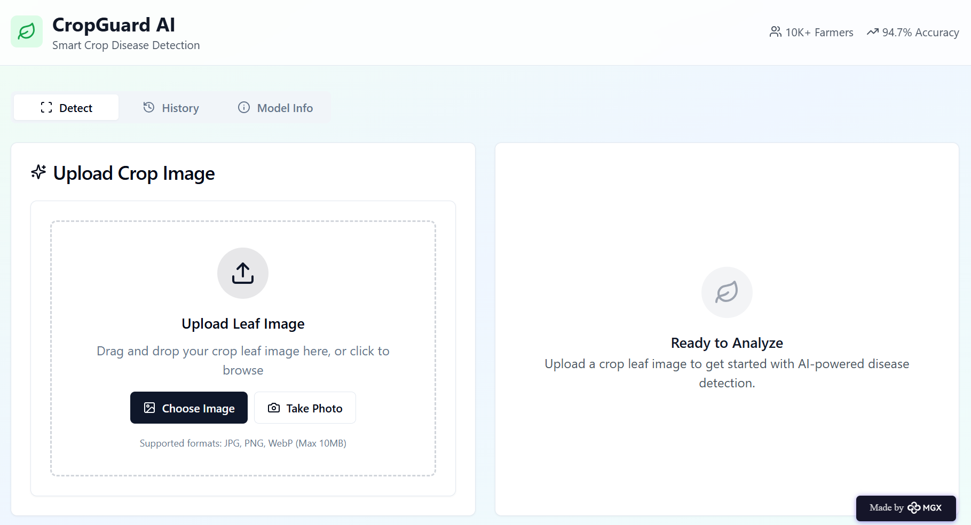

Internal Working of tool:

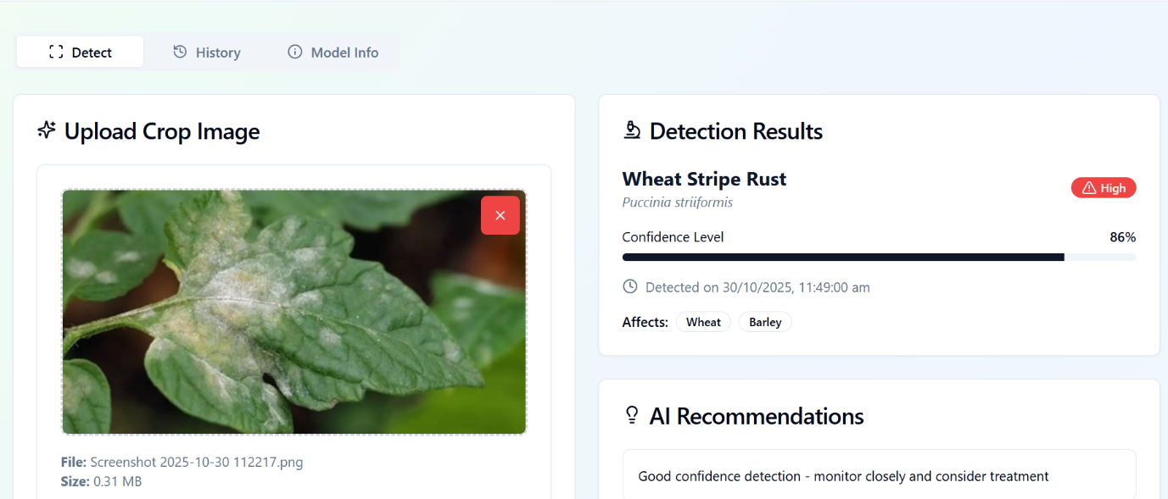

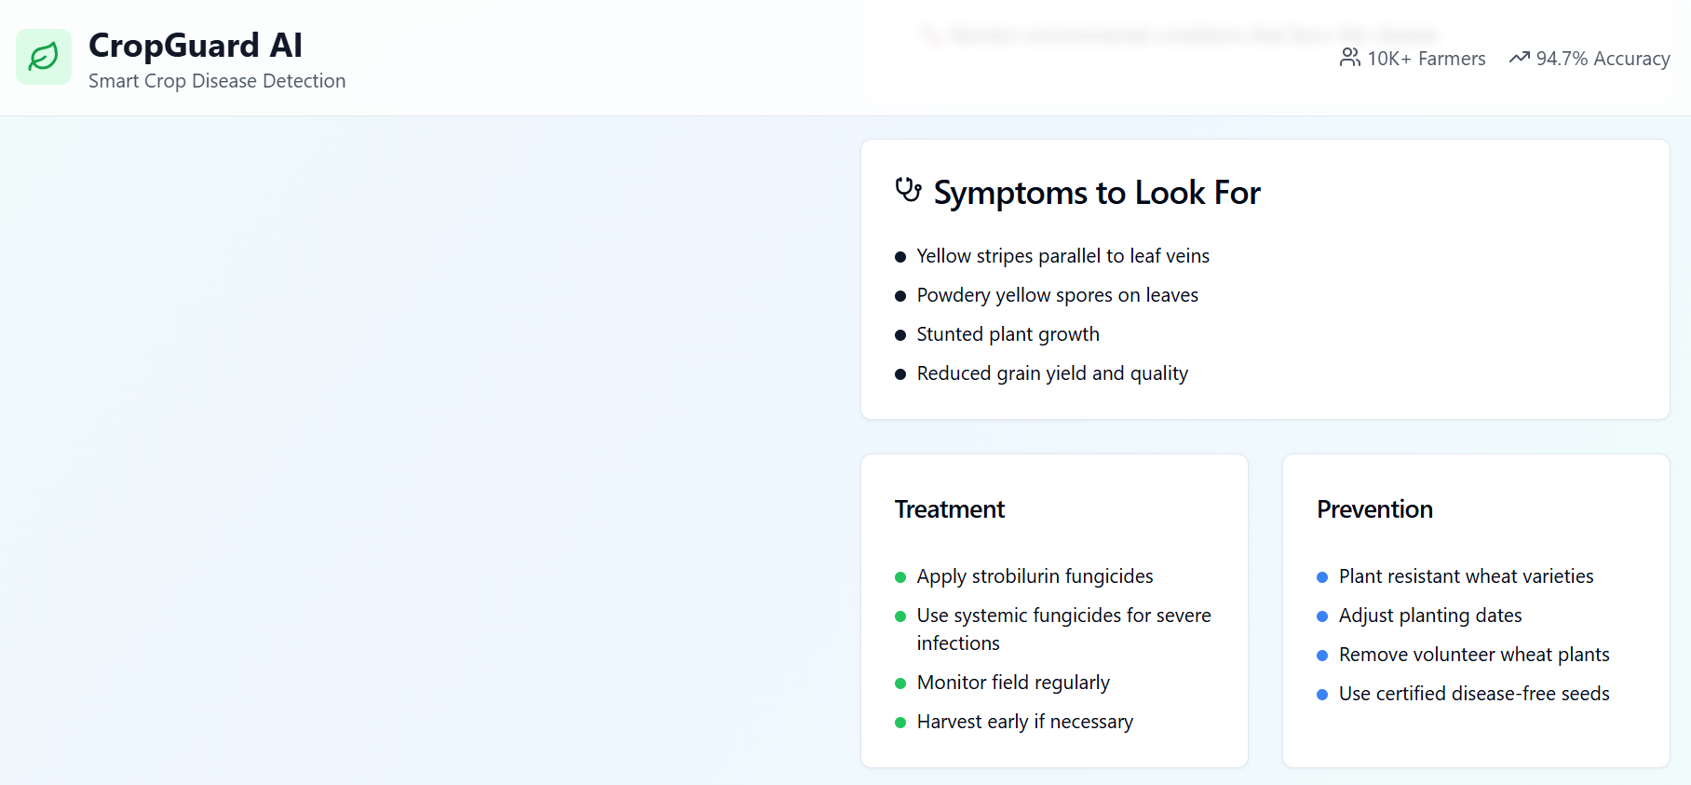

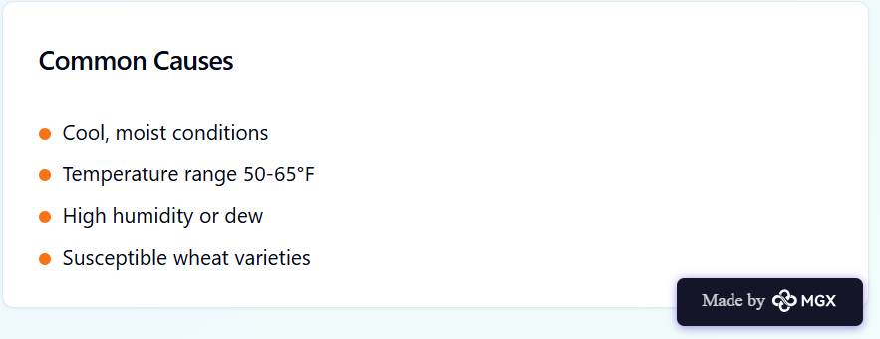

*Step 7: Test – Getting Feedback*

* Who did I share my solution with?

I shared my solution with:

1. **A local farmer** – to understand the practicality of using it in real farming conditions.
2. **An agriculture student** – to get insights on common crop diseases and usability.
3. **A computer science mentor** – to receive feedback on the AI model and design.

What feedback did I receive?

**Feedback: Pros and Cons**

**Pros:**

* **The app is easy to use and accessible for non-technical users.**
* **The AI model gives quick and reliable results for disease detection.**
* **The idea is innovative and has real-world impact on farmers’ lives.**
* **The UI design is clean and visually appealing.**

**Cons:**

* **Needs support for multiple regional languages for wider accessibility.**
* **Accuracy could improve with a larger and more diverse dataset.**
* **The app currently requires internet, which might be a limitation in rural areas.**
* **Fertilizer or pesticide suggestions could be added for more practical value.**

**My Response for The Feedback:**  
I took the feedback positively and used it to refine my project further. I plan to **expand the dataset** with more images to increase accuracy and **add regional language options** so that farmers across different areas can use it easily. I also aim to introduce an **offline mode** for areas with poor connectivity and a **recommendation feature** that suggests fertilizers and treatments based on detected diseases. Moving forward, I’ll continue **testing the app with real users** to make it more practical, reliable, and impactful for farmers.

👍 What works well:

**What Works Well**

1. The **AI model accurately identifies** common crop diseases using image inputs.
2. The **user interface is simple and intuitive**, making it easy for farmers to navigate.
3. The **processing speed is fast**, providing instant results after uploading an image.
4. The **visual design and color scheme** reflect an agricultural theme that users appreciate.
5. The project effectively **demonstrates the real-world use of AI in agriculture**, bridging technology with farming.

🔧 What needs improvement:

1. The **accuracy of detection** can be improved by training with a **larger and more diverse dataset**.
2. Needs **support for multiple regional languages** to reach a wider audience.
3. The system should include an **offline mode** for farmers with poor internet access.
4. Adding **fertilizer and pesticide recommendations** would make it more practical.
5. The app could use a **notification feature** to remind farmers of regular plant health checks.
6. **Model optimization** is needed to reduce processing time on low-end devices.

*AI Tools you can use for Step 6-7:*

**ChatGPT/Perplexity AI/Claude AI/Canva AI/Chatling AI/Figma AI/Metamgx/Gamma AI**: You can use these tools to build solutions/models or mock-up dummy prototypes

***Day 4: Showcase***

*Step 8: Presenting my Innovation:*My innovation, the **AI-Based Crop Disease Detection System**, uses **artificial intelligence and computer vision** to help farmers identify plant diseases quickly and accurately. By simply uploading or capturing a photo of a crop leaf, the system analyzes it using a **Convolutional Neural Network (CNN)** and provides instant results with the **disease name, cause, and suggested treatments**.

This innovation makes **modern AI technology accessible to farmers**, reduces crop loss, and promotes **smart, sustainable agriculture**. It bridges the gap between technology and farming, showing how AI can directly improve lives and productivity in rural areas.

**Impact:** This project creates a **positive impact on agriculture and farmers’ livelihoods** by enabling early detection of crop diseases, reducing losses, and improving productivity. It helps **farmers make data-driven decisions** instead of relying on guesswork. By making AI tools accessible and easy to use, the system encourages **smart farming practices** and supports **sustainable agriculture** for future generations.

**<SHOWCASE YOUR INNOVATION TO YOUR PEERS>**

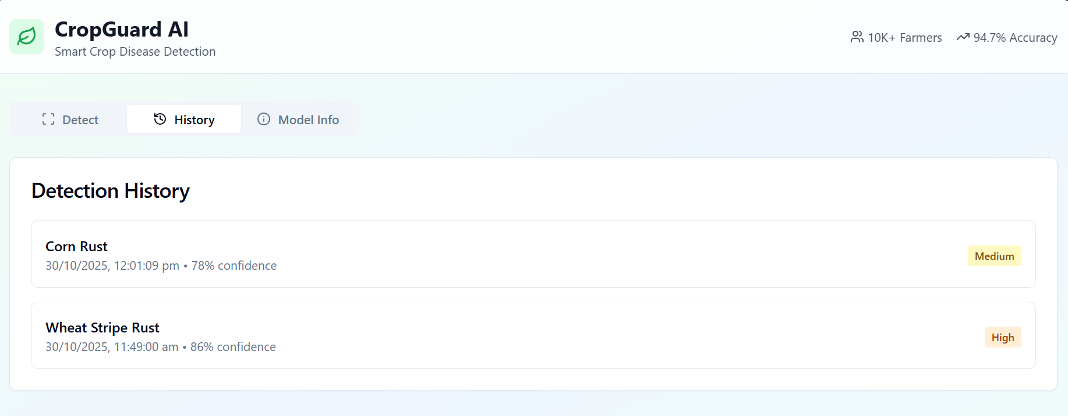

*Step 9: Reflections*

* What did I enjoy the most during this project-based learning activity?

I enjoyed **designing and training the AI model** the most, as it gave me a deeper understanding of how technology can solve real-world problems. Seeing the model correctly detect diseases from leaf images was really exciting and motivating. I also loved the **creative part of building the app interface**, where I could blend **technology with design and innovation**. The whole process made me feel more confident about using AI to make a real social impact.

What was my biggest challenge during this project-based learning activity?

My biggest challenge was **collecting and preparing the dataset** for training the AI model. Finding good-quality images of diseased and healthy leaves, cleaning the data, and ensuring it was balanced took a lot of time and patience. I also found it challenging to **improve the model’s accuracy** while avoiding overfitting. Understanding how different algorithms and parameters affected results required a lot of experimentation — but overcoming these challenges helped me **gain confidence and stronger technical skills**.

**Take-home task**

<https://github.com/SudeepUK33/AI-Based-Crop-Disease-Detection-System>

*AI Tools you can use for Step 8:*

**Canva AI:** You can use this to design your pitch document. Download your pitch document as a PDF file and upload on GitHub